

# ARTIFICIAL INTELLIGENCE

**AI-POWERED NUTRITION ANALYSER FOR FITNESS ENTHUSIASTS**

**TEAM ID : PNT2022TMID08145**

**A MINI-PROJECT REPORT**

*Submitted by*

MURALI KRISHNAN R - AC19UEC080(TL)

NIRMAL KUMAR S - AC19UEC087

MANJUNATHAN G - AC19UEC077

## JAYANTH M- AC19UEC060

***In partial fulfillment of the award of the degree***

*of*

**BACHELOR OF ENGINEERING**

*in*

**ELECTRONICS AND COMMUNICATION ENGINEERING**

**ADHIYAMAAN COLLEGE OF ENGINEERING**

**HOSUR - 635130**

**ANNA UNIVERSITY: CHENNAI 600025**

**NOVEMBER 2022**

## 

## 1.ABSTRACT

Artificial intelligence (AI) as a branch of computer science, the purpose of which is to imitate thought processes, learning abilities and knowledge management, finds more and more applications in experimental and clinical medicine. In recent decades, there has been an expansion of AI applications in biomedical sciences. The possibilities of artificial intelligence in the field of medical diagnostics, risk prediction and support of therapeutic techniques are growing rapidly. The aim of the article is to analyze the current use of AI in nutrition science research. The literature review was conducted in PubMed. A total of 399 records published between 1987 and 2020 were obtained, of which, after analyzing the titles and abstracts, 261 were rejected. In the next stages, the remaining records were analyzed using the full-text versions and, finally, 55 papers were selected. These papers were divided into three areas: AI in biomedical nutrients research (20 studies), AI in clinical nutrients research (22 studies) and AI in nutritional epidemiology (13 studies). It was found that the artificial neural network (ANN) methodology was dominant in the group of research on food composition study and production of nutrients. However, machine learning (ML) algorithms were widely used in studies on the influence of nutrients on the functioning of the human body in health and disease and in studies on the gut microbiota. Deep learning (DL) algorithms prevailed in a group of research works on clinical nutrients intake. The development of dietary systems using AI technology may lead to the creation of a global network that will be able to both actively support and monitor the personalized supply of nutrients.

# TABLE OF CONTENTS

|  |  |  |
| --- | --- | --- |
| **SL**  **NO.** | **TITLLE** | **PAGE NO.** |
| **1** | **ABSTRACT** | **2** |
| **2** | **INTRODUCTION** | **5** |
| **2.1 PROJECT DESCRIPTION** | **5** |
| **2.2 Purposes** | **5** |
| **3** | **LITERATURE SURVEY** | **5** |
| **3.1 Existing problem** | **5** |
| **3.2 References** | **7** |
| **3.3 Problem Statement** | **8** |
| **4** | **IDEATION & PROPOSED SOLUTION** | **9** |
| **4.1 Empathy Map Canvas** | **9** |
| **4.2 Ideation & Brainstorming** | **10** |
| **4.3 Proposed Solution** | **11** |
| **4.4 Problem Solution Fit** | **12** |
| **5** | **REQUIREMENT ANALYSIS** | **13** |
| **5.1 Functional requirement** | **13** |
| **5.2 Non-functional Requirements** | **13** |
| **6** | **PROJECT DESIGN** | **14** |
| **6.1 Data Flow Diagram** | **14** |
| **6.2 Solution Architecture** | **14** |
| **6.3 Customer Journey Map** | **14** |
| **7** | **PROJECT PLANNING & SCHEDULING** | **15** |
| **7.1 Sprint Planning & Estimation** | **15** |
| **8** | **MODEL CODE** | **17** |
| **8.1 TEST CASES** | **21** |
| **8.2 Output** | **22** |
| **9** | **CONCLUSION** | **24** |
| **10** | **FUTURE SCOPE** | **24** |
| **11** | **APPENDIX** | **25** |
| **11.1 LINKS** | **25** |
| **11.1.1 Github** | **25** |
| **11.1.2 Youtube** | **25** |

## 2. INTRODUCTION

### 2.1 PROJECT DESCRIPTION

Food is essential for human life and has been the concern of many healthcare conventions. Nowadays new dietary assessment and nutrition analysis tools enable more opportunities to help people understand their daily eating habits, exploring nutrition patterns and maintaining a healthy diet. Nutritional analysis is the process of determining the nutritional content of food. It is a vital part of analytical chemistry that provides information about the chemical composition, processing, quality control and contamination of food. The main aim of the project is to build a model which is used for classifying the fruit depending on the different characteristics like color, shape, texture etc. Here the user can capture the images of different fruits and then the image will be sent to the trained model. The model analyzes the image and detects the nutrition based on the fruits like (Sugar, Fibre, Protein, Calories, etc.).

### 2.2 Purposes

The AI model can be used as a reference for nutrition surveys and personal nutrition analysis. Nutritional intake is the basis for human growth and health, and the intake of different types of nutrients and micronutrients can affect health. Most diseases are inextricably linked to diet.

## 3. LITERATURE SURVEY

### 3.1 Existing problem

Neutrino delivers nutrition-based data services and analytics to its users and wants to turn into a leading source of the nutrition-related platform .The platform employs NLP and mathematical models from the optimization theory as well as predictive analysis to enable individualized data compilation.

The application relies on Artificial Intelligence to produce custom data related to smart calorie counter powered by AI. Their artificial intelligence learns an individual’s tastes, preferences , and body type. All of this is packaged in a comprehensive nutrition and activity tracker.

1.Artificial intelligence in food science and nutrition Information Technologies Institute(ITI) Kosmas Dimitropou los April 2019 Published by Oxford University Press on behalf of the International Life Sciences Institute.

Advantage:

Tells exactly what to eat according to the body type. All of this is packaged in a comprehensive nutrition and activity tracker Disadvantage:

The AI system may not always make the right decisions, but it will eventually learn from the errors and adjust its decision making processes to improve over time.

2. Artificial Intelligence in Nutrients Science BALAKRISH NA .Y JUNE2022

Advantage:

Creation of a global network that will be able to both actively support and monitor the personalized supply of nutrients.

Disadvantage:

The AI System May Be Buggy At First it can take time to work correctly This is normal.

3.AI-Based Dietician Professor, Department of Computer Science, Dayananda Sagar Academy of Technology April 2022 .

Advantage:

Helps the user to interact better with the system, Provide information to the system as input and take the recommended diet plan as output .

Disadvantage:

Doesn't have acknowledgeable dietician Don't value customer time Worst service.

### 3.2 References

1.McCarthy J., Minsky M., Rochester N., Shannon C.E. A Proposal for the Dartmouth Summer Research Project on Artificial Intelligence. [(accessed on 6 November 2020)].

2.Demirci F., Akan P., Kume T., Sisman A.R., Erbayraktar Z., Sevinc S. Artificial neural network approach in laboratory test reporting:Learningalgorithms.Am. J. Clin. Pathol. 2016;146:227237. doi: 10.1093/ajcp/aqw104. [PubMed] [CrossRef].

3.Buisson J.-C. Nutri-Educ, a nutrition software application for balancing meals, using fuzzy arithmetic and heuristic search algorithms. Artif.Intell.med.2008:42:213-2227. doi:10.1016/j.artme d. 2007.12.001. [PubMed] [CrossRef].

4.Yu D.-J., Hu J., Yan H., Yang X., Yang J.-Y., Shen H.-B. Enhancing proteinvitamin binding residues prediction by multiple heterogeneous subspace SVMs ensemble. BMC Bioinform. 2014;15:297. doi: 10.1186/1471-2105-15-297. [PMC free article] [PubMed] [CrossRef] [Google Scholar].

5.Gedrich K., Hensel A., Binder I., Karg G. How optimal are computercalculated.optimal.diets? Eur.J.Clin. Nutr. 1999;53:309 - 318.doi:

10.1038/sj.ejcn.1600727. [PubMed] [CrossRef] [Google Scholar]

6. Lo F.P.-W., Sun Y., Qiu J., Lo B. Food volume estimation based on deep learning view synthesis from a single depth map. Nutrients. 2018;10:2005. doi: 10.3390/nu10122005. [PMC free article] [PubMed] [CrossRef] [Google

Scholar].

7.Fang S., Shao Z., Kerr D.A., Boushey C.J., Zhu F. An end-to-end image-based automatic food energy estimation technique based on learned.energy.distribution.images:Protocol.and.methodology. Nutrients. 2019;11:877.doi: 10.3390/nu11040877. [PMC article] [PubMed] [CrossRef] [Google Scholar].

8. Ji Y., Plourde H., Bouzo V., Kilgour R.D., Cohen T.R. Validity and usability of a smartphone image-based dietary assessment app compared to 3-day food diaries in assessing dietary intake among canadian adults: Randomized controlled trial. JMIR Mhealth Uhealth. 2020;8:e16953.doi: 10.2196/16953. [PMC article] [PubMed] [CrossRef] [Google Scholar]

9.Tragomalou A., Moschonis G., Manios Y., Kassari P., loakimidis I., Diou C., Stefanopoulos L., Lekka E., Maglaveras N., Delopoulos A., et al. Novel ehealth applications for the management of cardiometabolic risk factors in children and adolescents in Greece. Nutrients. 2020;12:1380.doi:

10.3390/nu12051380. [PMC free article] [PubMed] [CrossRef] [Google Scholar].

10. Naushad S.M., Janaki Ramaiah M., Pavithrakumari M., Jayapriya J., Hussain T., Alrokayan S.A., Gottumukkala S.R., Digumarti R., Kutala V.K. Artificial neural network-based exploration of gene-nutrient interactions in folate and xeno-biotic metabolic pathways that modulate susceptibility to breast cancer. Gene.2016;580:159FF168.doi:10.1016/j.gene.2016.01.023. [CrossRef] [Google Scholar]

### 3.3 Problem Statement

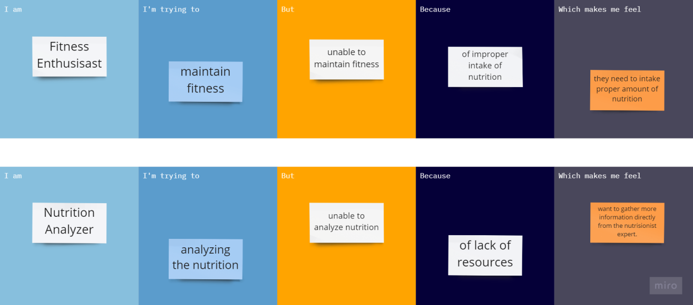

## 4. IDEATION & PROPOSED SOLUTION

### 4.1 Empathy Map Canvas

An empathy map is a simple, easy-to-digest visual that captures knowledge about a user’s behaviours and attitudes.

It is a useful tool to help teams better understand their users.

Creating an effective solution requires understanding the true problem and the person who is experiencing it. The exercise of creating the map helps participants consider things from the user’s perspective along with his or her goals and challenges.

|  |  |  |  |  |  |
| --- | --- | --- | --- | --- | --- |
| **Problem**  **Statement (PS)** | **I am**  **(Customer)** | **I’m**  **trying to** | **But** | **Because** | **Which makes**  **me feel** |
| PS-1 | Fitness freak | build the muscle | I don’t  know how many  calories i want to eat | Lack of knowledge | angry  and feel  bad |
| PS-2 | Patient | eat  balanced  diet | I am not able to eat | I don’t  know  nutrition content proper nutrition food | helpless |

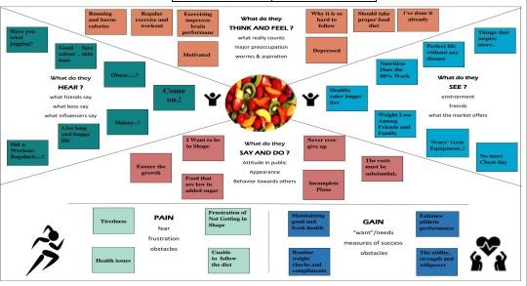

### 4.2 Ideation & Brainstorming

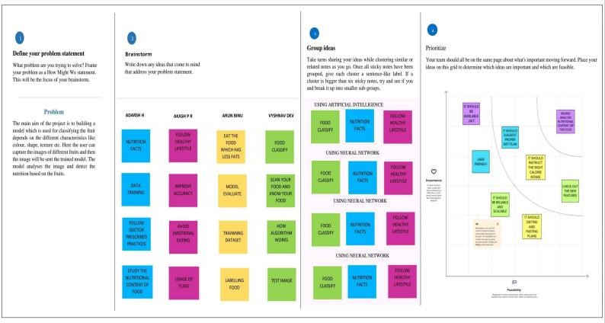

### 4.3 Proposed Solution

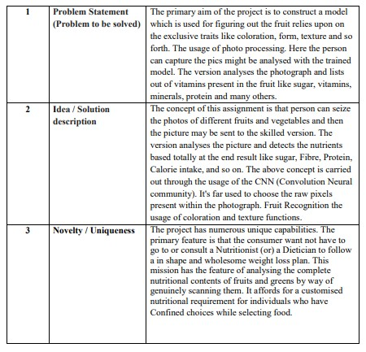

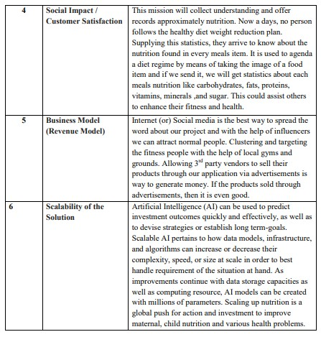

### 4.4 Problem Solution Fit

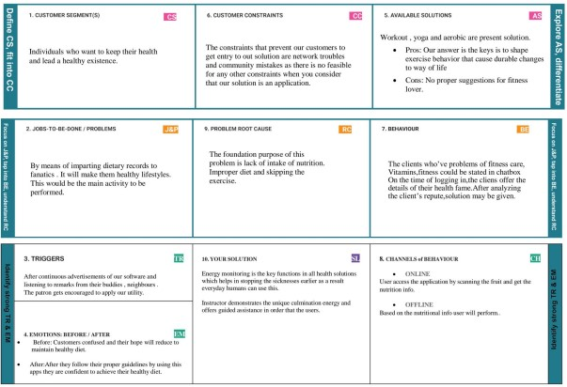

## 5. REQUIREMENT ANALYSIS

### 5.1 Functional requirement

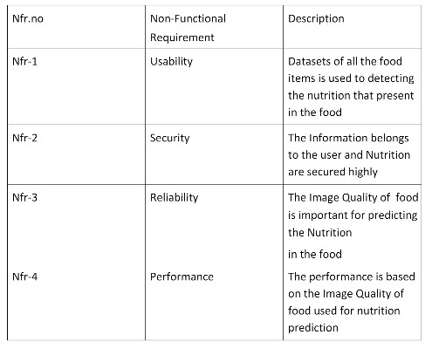

**5.2 Non-functional Requirements:**

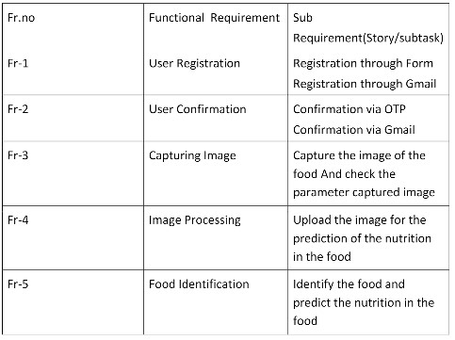

## 6 PROJECT DESIGN

### 6.1 Data Flow Diagram

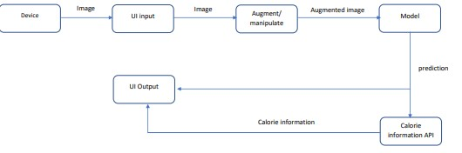

### 6.2 Solution Architecture

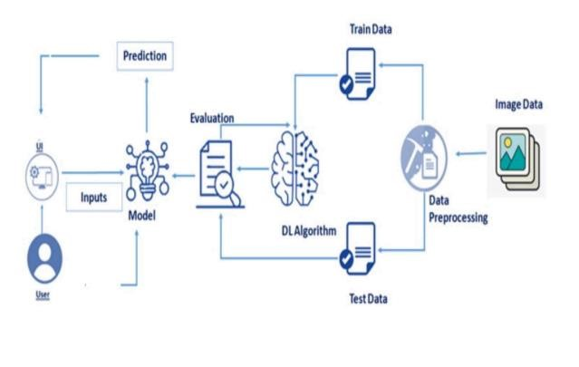

### 6.3 Customer Journey Map

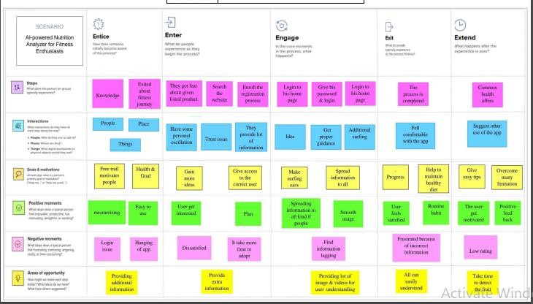

## 7. PROJECT PLANNING & SCHEDULING

### 7.1 Sprint Planning & Estimation

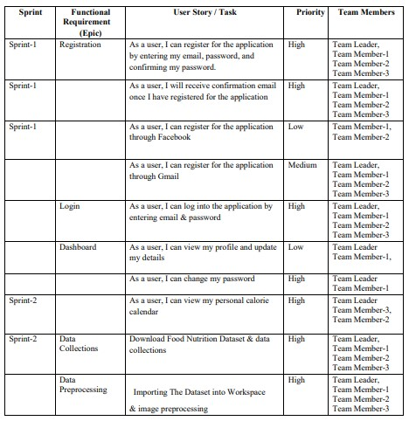

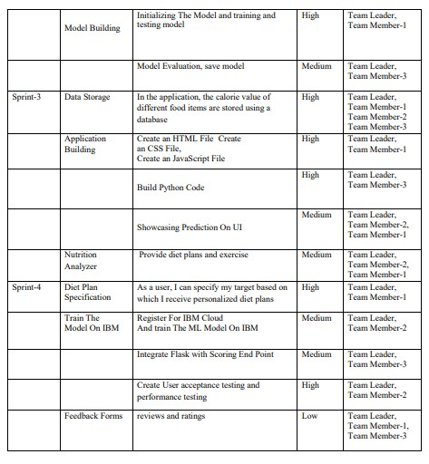

## 8. MODEL CODE

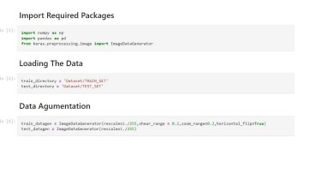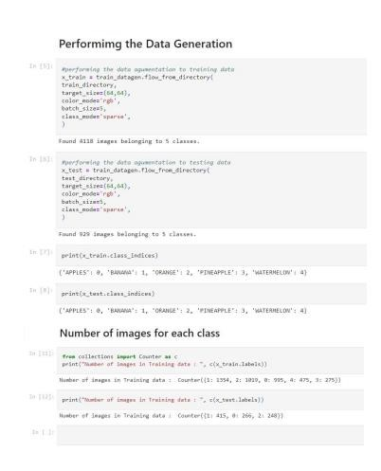

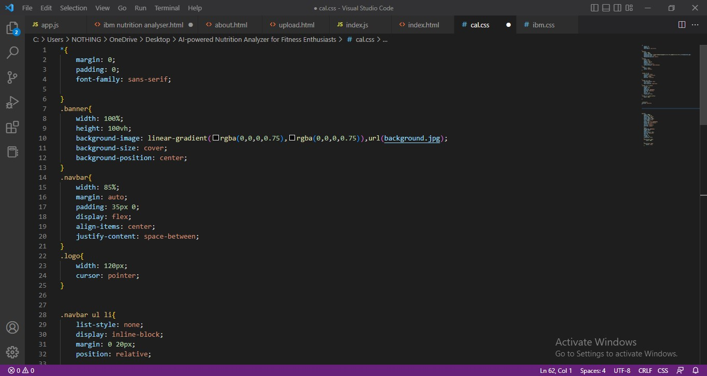

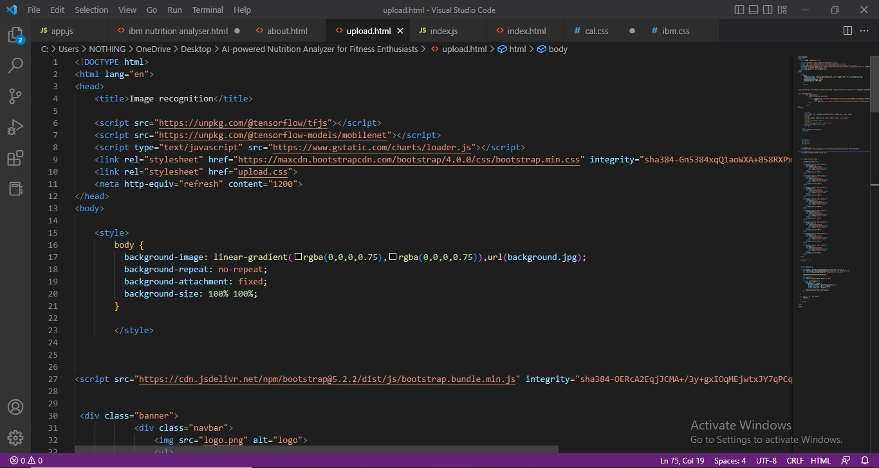

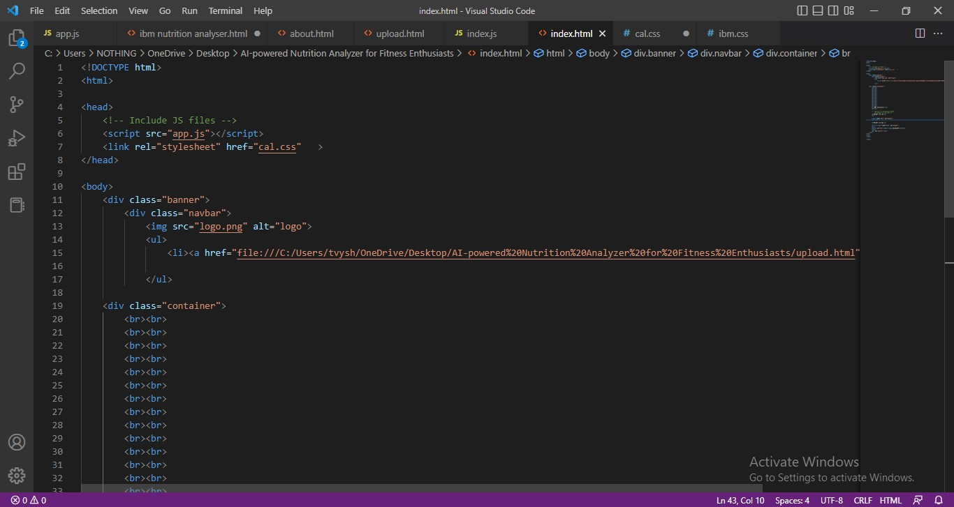

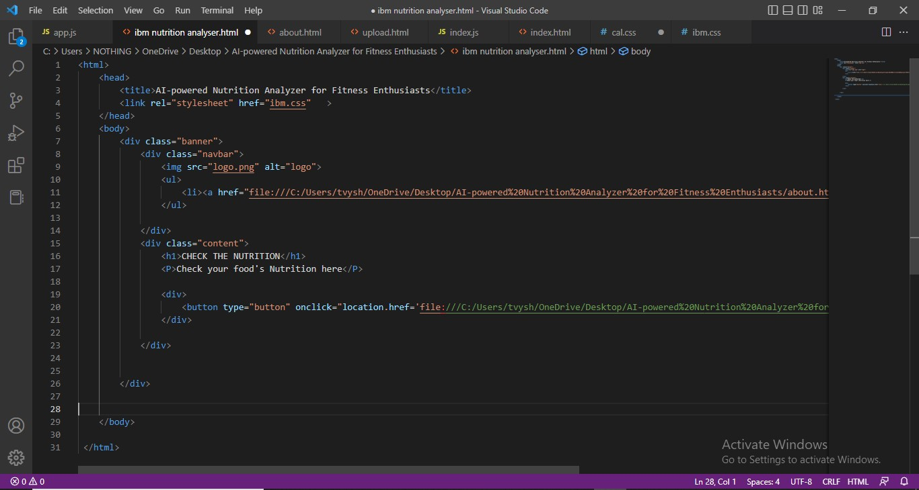

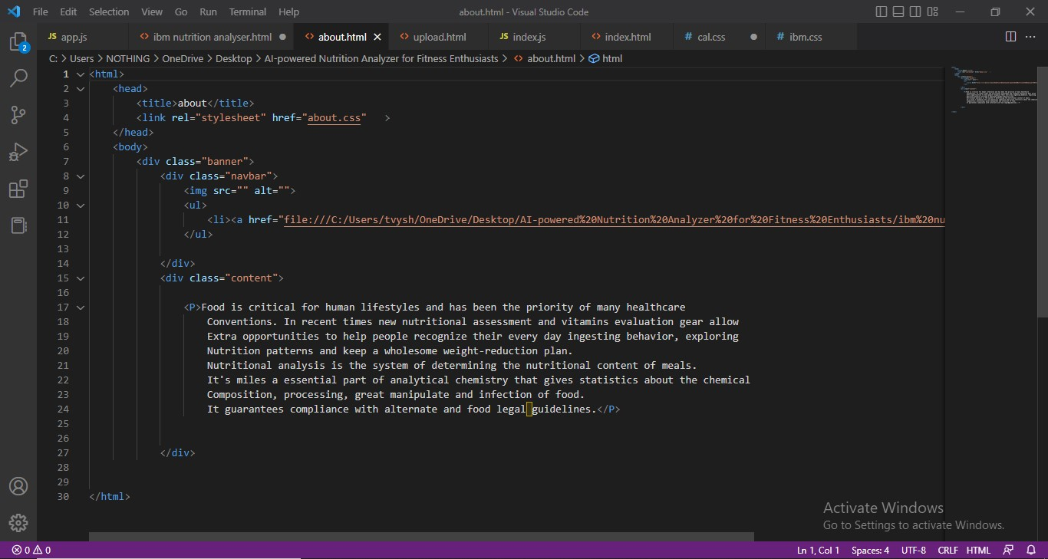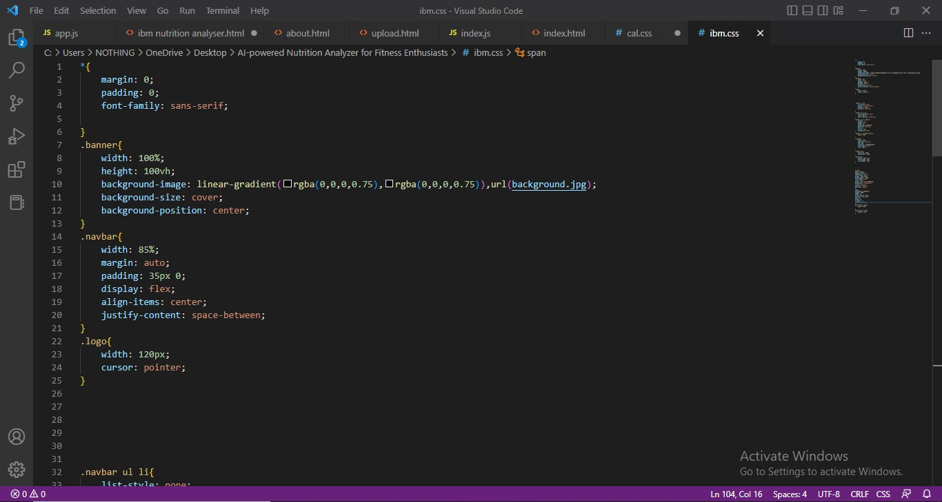

### 8.1 TEST CASES

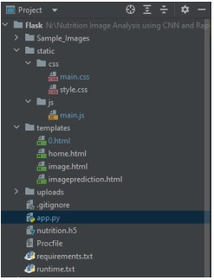

### 8.2 Output

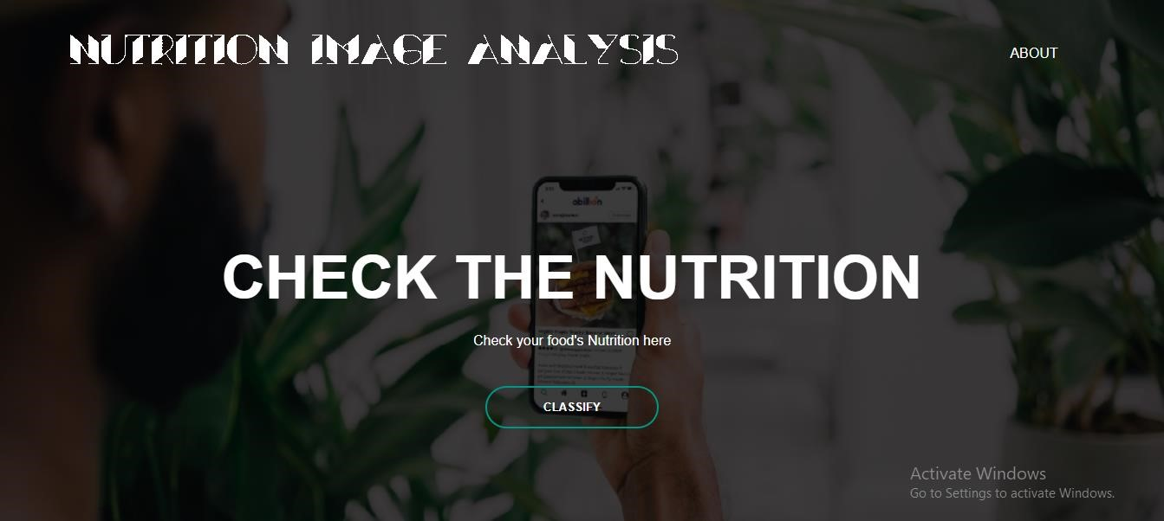

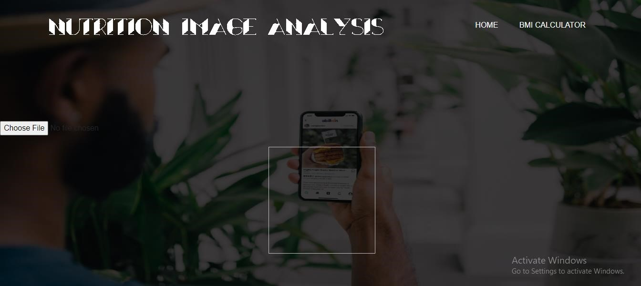

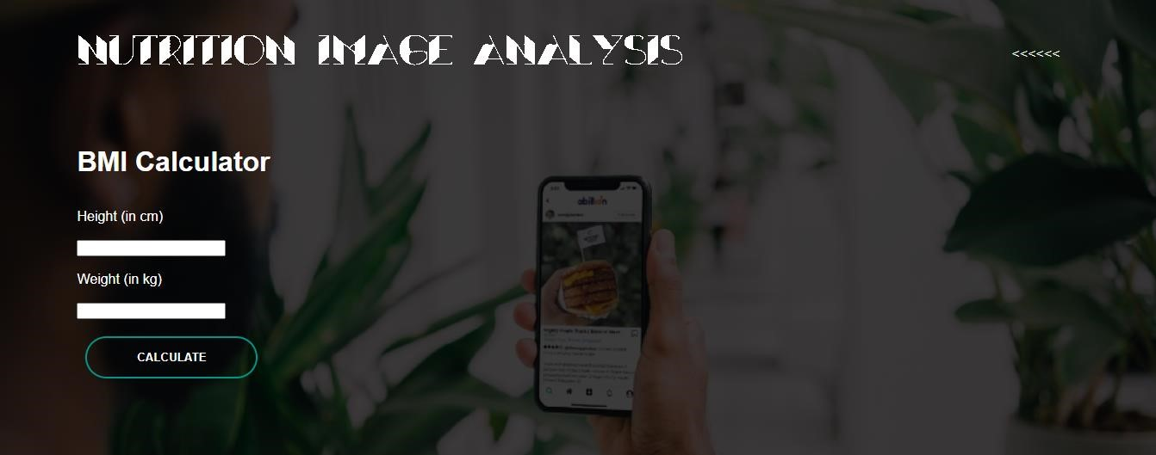

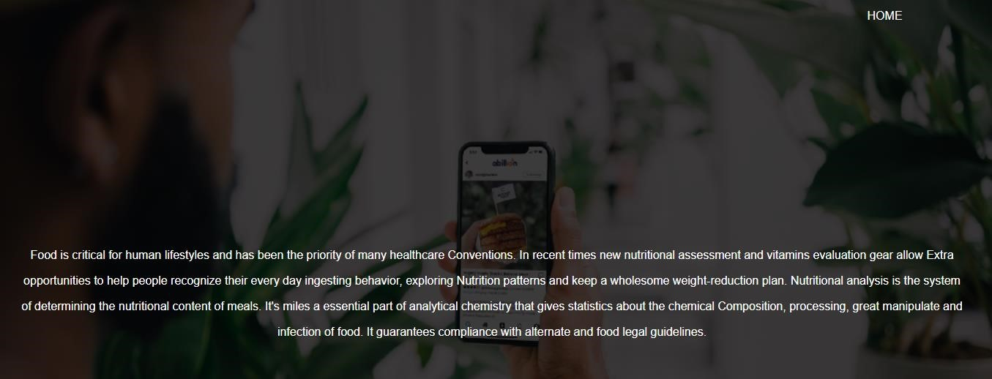

## 9.CONCLUSION

During this project, we had the option to investigate some portion of the profound learning algorithms and find qualities and shortcomings. We picked up information on deep learning, and we got a productthat can perceivefruits from pictures.A new methodfor classifying fruitsusing convolutional neural network algorithm is proposed. The above listed results were obtained using 7 test samples taken out from the actual number of 2626 and 1050 images used for training and testing. The above algorithm was coded and tested using anaconda software. Different fruits varieties that had different backgrounds were taken for training and testing. The proposed algorithm gave 98% accuracy rate. This project explores a fruits classification based on CNN algorithm.The accuracy and loss curves were generated by using various combinations of hidden layers for five cases using fruits. CNN gave better performance to attain better fruit classification. We trust that the outcomes and strategies introduced in this projectcan be additionally extendedto a greater task. From our perspective, one of the principal goals is to improve the precision of the neural system. This includes further exploring different avenues regarding the structureof the system.

## 10. FUTURE SCOPE

Hopefully, in the future, this project can be extended with a larger dataset having more categories of fruits & vegetables. We will also have the plan to implement some other CNN based models to compare the accuracy on the same dataset, can also work on some more features for grading and classification, which can identify type of disease and/or texture structure of fruits. All these are future direction.

## 11. APPENDIX

In the Dietary Reference Intake (DRI) nutrient reports, the Adequate Intake (AI) has been estimated in a number of different ways. Because of this, the exact meanings and interpretations of the AIs differ. Some AIs have been based on the observed mean intake of groups or subpopulations that are maintaining health and nutritional status consistent with meeting the criteria for adequacy. However, where reliable information about these intakes was not available, or where there were conflicting data, other approaches were used. As a result, the definition of an AI is broad and includes experimentally estimated desirable intakes. These varying methods of setting an AI make using the AI for assessing intakes of groups difficult. When the AI is based directly on intakes of apparently healthy populations, it is correct to assume that other populations (with similar distributions of intakes) have a low prevalence of inadequate intakes if the mean intake is at or above the AI. For nutrients for which the AI was not based on intakes of apparently healthy populations, a group mean intake at or above the AI would still indicate a low prevalence of inadequate intakes for that group but there is less confidence in this assessment

### 11.1 LINKS

#### 11.1.1 Github Link

https://github.com/IBM-EPBL/IBM-Project-16192-1659609411

**11.1.2 Video** link: https://drive.google.com/file/d/12mJOj_-GtYDrvhHcyjuTfqLFbtmfKQZS/view?usp=sharing